**Overview**

Big Mountain Resort had a recent improvement to the capital infrastructure of the ski area by adding another ski lift. Expected costs for maintaining and operating the new equipment is expected to run 1.54 million dollars annually.

Executives of Big Mountain Resort are exploring ways to offset those expenses and maintain current profitability levels.

**Data and Modeling**

The data set used to run the analysis consisted of 300 ski areas in the US with fields describing various aspects of a ski resort. Information collected included types and number of chairlifts, days of operation, projected operation days, current weekday and weekend lift ticket prices, states, regions, physical attributes like the elevation of the summit and base, skiable acreage, night skiing acreage, snowmaking acreage, number of runs, longest run, terrain parks for snowboarding.

The modeling approach was to evaluate each dataset and remove some data that is unmanageable for the location. These static values included base elevation, summit elevations, region, and state. Evaluating the MAE and EVA of each of these data combinations, the removal of the base elevation, summit elevation, region, and state was the most relative.

Big Mountain Resort charges the same rate for lift tickets on the weekend as they do on weekdays. We will run the multiple linear regressions of all the fields that have a financial impact on operations and maintenance of the resort to get a trend of costs across the country based on the features of each of the resorts and their ticket prices. This analysis will give a comparable price for lift tickets relative to all other resorts based on the value of the added service.

**Results**

A simple review of the executives’ request to offset the operational costs would be simple enough. Take the expected expenditures of $1.54 million and divide by paying customer tickets per year. Last year, approximately 350,000 tickets were sold. At that same rate of visitors, it would require a $4.40 raise to offset the additional operating costs. That is a pretty simple evaluation and not much room for error or thought of actual value compared to the industry.

Evaluating regression coefficients of Explained Variance Score (EVS) and Mean Absolute Error (MAE) were evaluated for the three initial models and found that the highest EVS and lowest MAE were associated with the model with the states, summit elevation, and base elevation removed. These results confirmed our thoughts on basing the evaluation of potential price update on the industry based on capital expenditure structures such as chair lifts and acreages of features would seem to be a basis for estimating value amongst Big Mountains peers.

The predicted value of the weekend ticket using the selected model was $88.77, or approximately $8 higher than last year.

**Conclusions**

Reviewing the predicted value of the lift tickets by viewing the costs of the tickets versus features. The below charts show the industry as a whole with the ‘blue’ dot representing the original lift ticket price and the ‘red’ dot the suggested lift ticket price. In chart 1 comparing ‘Total Chair Lifts’ to the current price shows little movement within the trend and still reflects that Big Mountain is quite a value in regards to getting up the mountain with close peers in the 80 to 100 pricing range typically has fewer chair lifts.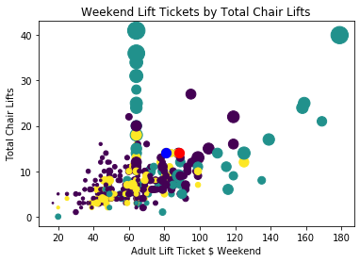

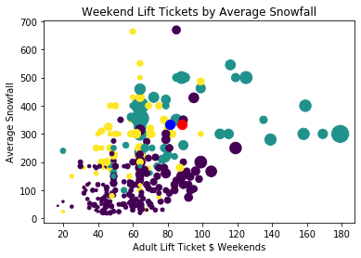

**Chart 1: Chair Lift vs Price of Lift Ticket**

Another view of the maintained value of Big Mountain Resort lift tickets is the ratio of average snowfall vs ticket prices. It is quite obvious that the old price (blue dot) and the new price (red dot) is generally higher in average snowfall than other ski resorts charging $80 plus per lift ticket. Without snow, there is not much skiing.

**Chart 2: Average Snowfall by Ticket Price**

Our conclusion is that the $7.77 estimated increase to the value of the lift tickets is reasonable and warranted in the current market.